1. Analizar a fondo Life360 y otras apps similares.

**Andres – Life 360**

First screen:

* Logo Life 360

Two options:

1. Get started button: if you click this option –> “Let’s get started what’s your number?” Country code + cell phone
2. Already have an account? Sign in

Pricing Options de Live360:

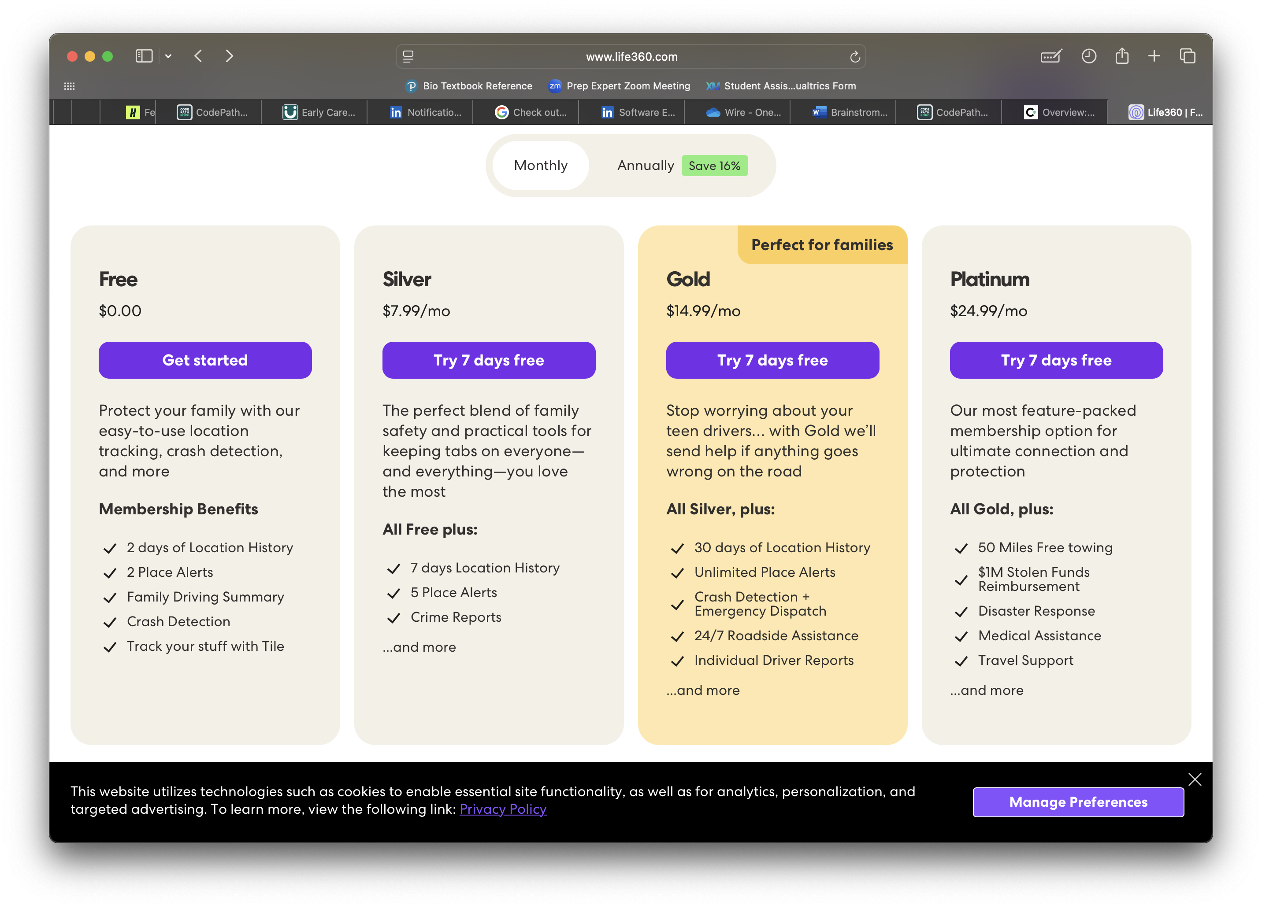

I already had an account, so I clicked on **option 2:**

2. Definir claramente qué queremos que tenga la app, enfocándonos en los factores diferenciadores.

3. Una vez tengamos una idea clara, buscar un(a) UX/UI designer que nos ayude con el diseño.

4. Empezar a escribir el código y, si es necesario, buscar personas adicionales para apoyar en esa parte.

-------------------------------------------------------------------------------------------------------------------------

**ChatGPT:**

### **🔍 1. Privacy-First Design**

* **Problem:** Life360 has faced criticism for invasive tracking and over-monitoring, especially by parents or partners.
* **Your Opportunity:** Offer **granular privacy controls** (e.g., temporary location sharing, “ghost mode,” zone-based visibility).
* Consider **anonymous alerts** or “just-in-case” location updates without real-time tracking.

### **🛡️ 2. Safety-First, Not Surveillance-First**

* **Problem:** Life360 is often seen more as a tracker than a safety tool.
* **Your Opportunity:** Position your app around **protection, emergency response, and social trust**, not surveillance.
* Add features like:
  + **Emergency signal via discreet tap**
  + **Fake call or escape plan**
  + **Verified “safety wires” (trusted network feature)**

### **💬 3. Social + Cultural Layer**

* **Problem:** Life360 lacks a **community feel** or cultural customization.
* **Your Opportunity:** Embrace local culture and social dynamics:
  + Customizable **chat groups for families, friends, partners, or events**
  + **Localized interface** (slang, colors, visual style)
  + Integrate **cultural safety tips** (e.g., what to do if stopped in the street in Bogotá or Rio)

### **🌎 4. Offline Mode or Low-Data Version**

* **Problem:** Latin America has inconsistent internet coverage and expensive mobile data.
* **Your Opportunity:** Offer a **lightweight or offline-compatible mode** for emergency check-ins or location caching.

### **🧠 5. AI-Powered Safety Insights**

* Detect **unusual movement patterns**, suggest **safer routes**, or send **proactive alerts** like:

“You usually reach home by 8 PM—do you want to send a delay notification to your wire?”

### **🧩 6. Integrations and Expansions**

* Panic button linked to **local emergency numbers** (with auto-translations)
* **Insurance partnerships** (e.g., lost phone, assault protection)
* **Wearables or fashion accessory integration** (like your bracelet idea)
  + Life360 created tile which is like an airtag but cheaper, and integrated seamlessly with the app (essentially a competitor to this wearable idea, except it’s not a wearable so the marketing strategy should be to advertise as a wearable, fashionable, it’s a fashion statement --> later can transition to becoming an apple watch or smart watch app (basically making the bracelet pointless) so think about how to market this wearable technology in a form that’s long lasting, people wanna wear both or choose the bracelet over apple watch

### **📣 7. Hyperlocal Marketing Strategy**

* Partner with:
  + **Schools and universities** (for student safety)
  + **Nightlife venues** (for personal safety at night)
  + **Rappi/Didi/Uber-style delivery networks** for worker protection

### **📱 Find My (Apple) – Strategic Competitor Breakdown**

#### **🔍 1. Privacy-First Design**

**Problem:**  
Find My is deeply embedded into the Apple ecosystem, offering limited visibility or customization around **who sees what, when**. Once someone has access to your location, there’s no in-app granularity beyond removing them entirely.

**Your Opportunity:**

* Offer **timed** sharing (e.g., "Share until 8 PM")
* **Blurred location zones** (e.g., “in the neighborhood” but not precise)
* “Invisible” mode with **decoy location pulses** for high-risk moments
* **Auto-expire** shares or enable sharing *only if an emergency signal is triggered*

#### **🛡️ 2. Safety-First, Not Surveillance-First**

**Problem:**  
Find My is utility-focused, not purpose-driven around safety. No panic button, no predictive safety logic, no check-ins.

**Your Opportunity:**

* Add **AI-powered check-in nudges** (e.g., “Still at club X, want to check in with your group?”)
* **One-tap alert** sends pre-set message and location
* **Safety route sharing** that lets someone follow without continuous GPS drain
* Promote the idea of a **“Safety Companion”**, not just a map pin

#### **💬 3. Social + Cultural Layer**

**Problem:**  
Find My is extremely **transactional**. No chat, no group dynamics, no cultural context.

**Your Opportunity:**

* Enable **culturally relevant safety tips**, like how to handle specific situations in cities like Lima or Medellín
* **Latino-inspired UI themes**, with vibrant visuals and intuitive interactions
* Use **family-oriented language and groups** (e.g., “mi círculo seguro”) instead of technical terms
* Build a **community layer**, e.g., “trusted friends near me,” local crime reports, or peer alerts

#### **🌎 4. Offline or Low-Data Compatibility**

**Problem:**  
Find My needs iCloud and internet access; it’s almost useless in data-restricted environments.

**Your Opportunity:**

* Enable **Bluetooth-based mesh alerts** (can work via nearby phones)
* Offer **cached location sharing** and **SMS-based check-ins**
* Develop a **Lite app version** for underpowered devices

#### **🧠 5. AI Safety Intelligence**

**Problem:**  
No intelligence; it's reactive, not proactive.

**Your Opportunity:**

* Notify users if someone they’re following deviates from routine
* Suggest safe meeting spots dynamically based on time, lighting, local reports
* Predict risks based on movement + context (e.g., rapid movement at odd hours in a high-risk zone)

#### **🧩 6. Integrations + Hardware Edge**

**Problem:**  
Find My is limited to Apple devices + AirTags (which aren’t wearables and are often used for items, not people).

**Your Opportunity:**

* Launch **fashion-forward wearables** with hidden tech: bracelets, pendants, shoe clips
* Unlike AirTags, focus on **active safety features**, not just passive tracking
* Build **emotional branding**: “Not just a device—your guardian angel.”
* Expand to **Android + iOS**, covering the entire market unlike Find My

**Important:** As AirTags get banned or restricted in some countries due to stalking concerns, your wearable must highlight **consent-based sharing**, making it safer and more acceptable.

#### **📣 7. Hyperlocal & Emotional Marketing**

**Problem:**  
Apple markets broadly. No regional customization.

**Your Opportunity:**

* Partner with **LatAm influencers**, student orgs, and nightlife communities
* Campaigns like **“Llévame Contigo”** (Take me with you) or **“Nunca Solo”** (Never Alone)
* Offer **branded safety kits** to delivery riders (bracelet + app + training)
* Create viral stories around **real saves** using your tech

**🧠 2. Naming Ideas for the Wearable Tech (Bracelet)**

### **Concept: It’s more than a device — it’s a symbol of *personal freedom + protection*.**

|  |  |  |
| --- | --- | --- |
| **Name** | **Inspiration** | **Positioning Angle** |
| **Alma** | “Soul” in Spanish — poetic, human-centric | “Keep your soul safe wherever you go.” |
| **Senda** | Means “path” or “journey” | “Your path, your safety, your way.” |
| **Lazo** | Spanish for “bond,” “tie,” or “ribbon” | “Stay connected. Stay protected.” |
| **Onda** | “Wave” or “vibe” — modern, fluid, youthful | “Send the right wave when something’s wrong.” |
| **WireBand** | Aligned with the app name, tech-forward | “Not just fashion — it’s your safety wire.” |
| **Kipu** | Inspired by Andean knots used for communication | “Modern protection rooted in ancient wisdom.” |